Visual Arguments

Kun Yang

ENG 112-100

Margret Neff

Due:6/1/2015

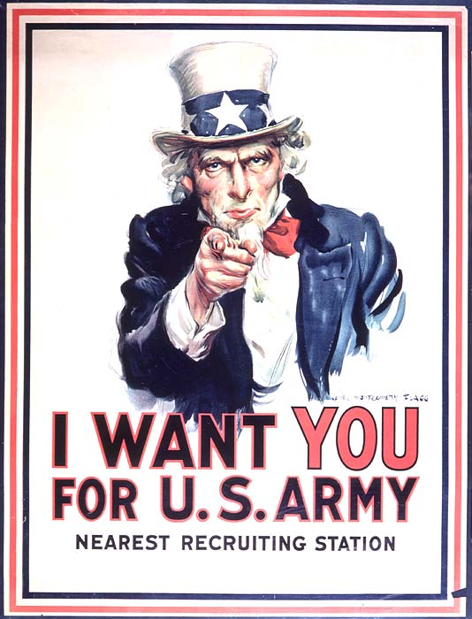

Figure 1: James Montgomery Flagg(1877-1960) “I Want You for the U.S. Army” Lithograph,1917

The original poster was painted by James Montgomery Flagg, July 6th, 1916. It was issued of Leslie’s Weekly “What Are You Doing for Preparedness?” where “Uncle Sam”, the magazine’s portrait figure became the world’s most famous poster.Over four million copies were printed between 1917 and 1918. It was used as an American army’s propaganda of recruiting soldiers during World War I, and it was also being reused during World War II to serve the same purpose, which was to recruit American into the U.S Army.

The “Uncle Sam” image was intended to show to the American citizen, because it was obvious that the slogan of this picture was stated in all caps“I WANT YOU FOR U.S. ARMY” it was created for the USA military in general, even though the picture was only referring to “U.S.ARMY”, however the background patriotic color was also indirectly intended to the whole USA military.

The red, white and blue patriotic color out frame directly gave such image that it was made for the American audiences. Another piece of evidence where the white American mid-age male figure pointing at the readers, where the male figure is wearing a blue jacket, white 1890s tall patriotic white hat, red bowtie, and a white shirt, therefore he seems to be someone who was a boss or political figure from the industrial revolution period, when American economy was at its booming period, which in a sense that the higher class of America also need “you” who were the readers to join the Army, in order to keep the peace around the world. The Uncle Sam figure was based on the model of Samuel Wilson, a meat packer from Troy, New York. “Samuel Wilson… Who supplied barrels of beef to the United States Army during the War of 1812. Wilson stamped the barrels with U.S. for United States, but soldiers began referring to the grub as Uncle Sam’s.”(Hisotry.Com)

This image used both Logos and Pathos from the rhetorical triangle, where the text “I Want You For U.S.ARMY” as the central expressive idea of this image, which is connected to the Logos From the rhetorical triangle. Meanwhile the White American Male figure in the background where he was pointing at the readers as a meaning that USA had chosen the readers who was the American citizen at the time as the candidates of the purpose of such image, which in a sense that the white American male focused on the audience, as the equivalence of the Pathos from the rhetorical triangle. This Image was quite effective, due to the description from the American Treasures of the Library of Congress, “over four million copies were printed between 1917 and 1918”(loc.gov) large amount of this image was produced during 1917 and 1918, numbers of copies reflected the effectiveness of the image as a whole.

This image had impressed me as motivation of joining the military, however figure one has its shortcoming, for example it strike readers that such image has included racist ideas, because at such period, the African American minorities were not heavily populated to the American society, therefore I think the image would had been better, if the image would conclude few different versions, which the background figure could be multi-racial. It would have been perfect if the female was also included in the image.

My first impression to the image was motivated with the fact that Uncle Sam pointed straight at me; I felt motivated based on the fact that I thought to myself which I had the obligation to serve the country.

Work cited

History.com Staff. “United States nicknamed Uncle Sam” A+E Networks. 2009

American Treasures of the Library: link<http://www.loc.gov/exhibits/treasures/trm015.html>